International Symposium

“Challenges in estimating the prevalence of female genital mutilation in the European Union and recommendations for future estimations”

Monday February 27, 2017: Sharing experiences on FGM prevalence estimations in Europe and USA

Chair: Marie Lesclingand

10.15 – 11.00 Registration and coffee
11.00 – 11.15 Welcome by Minister Sleurs (TBC)
11.15 – 11.30 Welcome by Adjunct-Director IGVM, Dr Stevens
11.30 – 11.45 Introduction and background to the symposium, Prof Dr Els Leye
11.45 – 12.15 FGM Risk Estimations on FGM in the EU – Jurgita Pecuriene, EIGE
12.15 – 12.45 Setting the scene: a situation analysis of prevalence studies in the European Union – Lotte De Schrijver
12.45 – 13.00 Q&A

13.00 – 14.00 Lunch

14.00 – 14.20 The prevalence study on FGM in Portugal – Dalila Cerejo
14.20 – 14.40 The prevalence study on FGM from the UK – Alison Mc Farlane
14.40 – 15.00 The prevalence study on FGM in Norway - Mai Mahgoub Ziyada
15.00 – 15.30 Q&A
15.30 – 16.00 Coffee Break
16.00 – 16.30 Methodological challenges in estimating FGM prevalence and pros and cons of some methods – Armelle Andro
16.30 - 17.00 Q&A and closure

Tuesday February 28, 2017: Lessons learned and recommendations

Chair: Sioban O’Brien Green, Trinity College, Ireland

09.30 – 09.45 Preparation of the study – Lotte De Schrijver
09.45- 10.30 Findings and lessons learned from piloting a methodology for direct estimations of FGM prevalence in Italy – Livia Ortensi
10.30 – 11.00 Presentation of the Recommendations for future research
11.00 – 11.30 Coffee Break

Chair: Katherine Brown, Coventry University

11.30 – 12.30 Debate and exchange with the audience on recommendations
12.30 – 12.45 Concluding remarks – Els Leye

Location:

Het Instituut voor de gelijkheid van vrouwen en mannen
Ernest Blerotstraat 1
B-1070 Brussel
Tel: 02/233 41 75

E-mail: gelijkheid.manvrouw@igvm.belgie.be

Link naar routebeschrijving

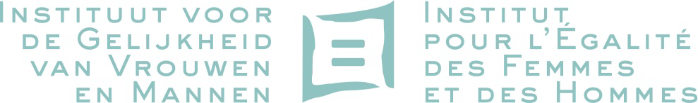

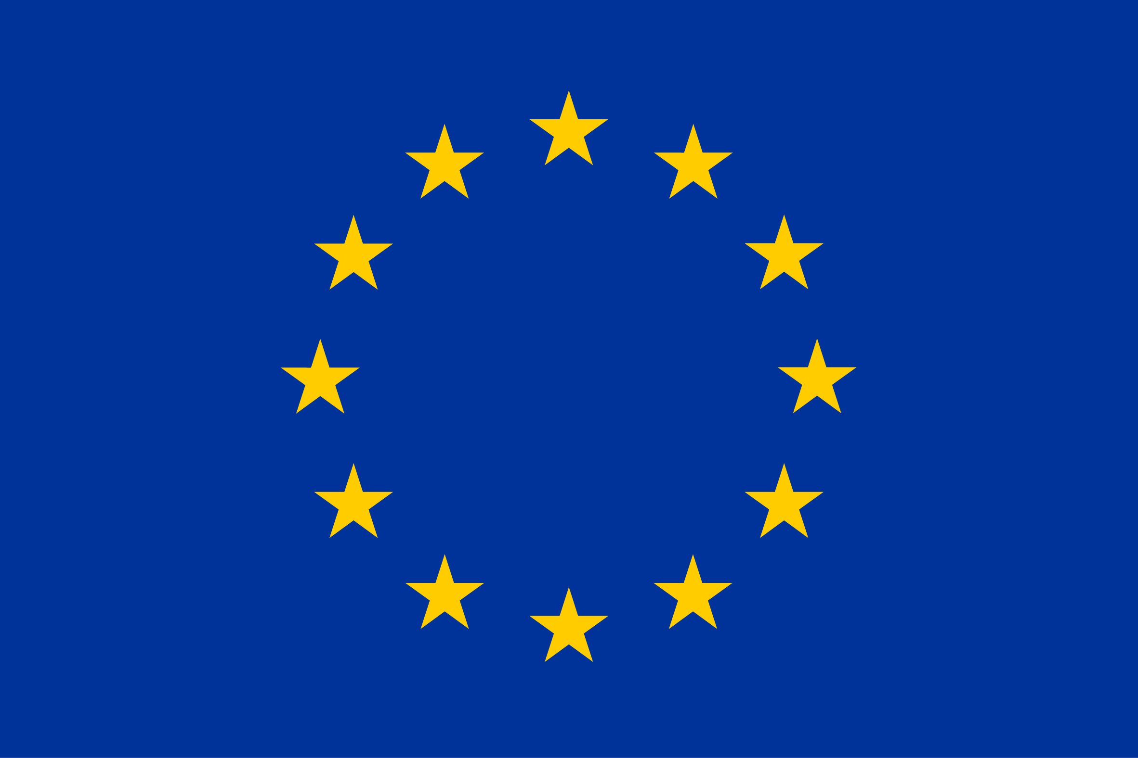

This project is funded
by the DAPHNE Programme
of the European Union

